COMPOUND MEASURES
Pearson Edexcel – Tuesday 19 May 2020 - Paper 1 (Non-Calculator) Higher Tier
1.
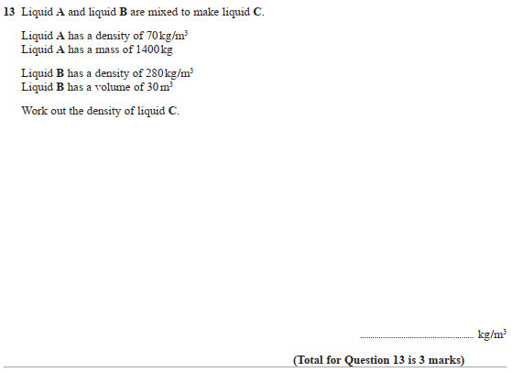

Pearson Edexcel - Tuesday 21 May 2019 - Paper 1 (Non-Calculator) Higher Tier
2.
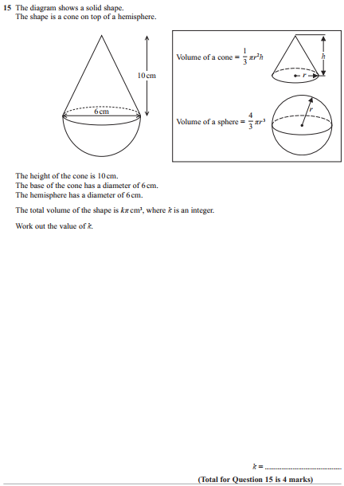

Pearson Edexcel - Tuesday 11 June 2019 - Paper 3 (Calculator) Higher Tier
3.
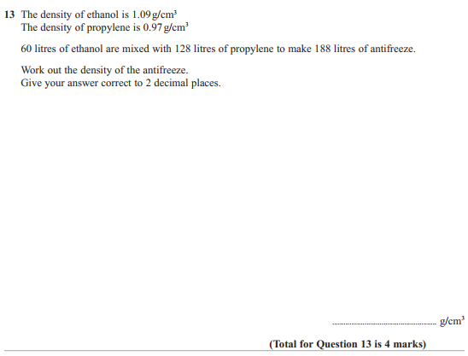

Pearson Edexcel - Thursday 8 November 2018 - Paper 2 (Calculator) Higher Tier
4.
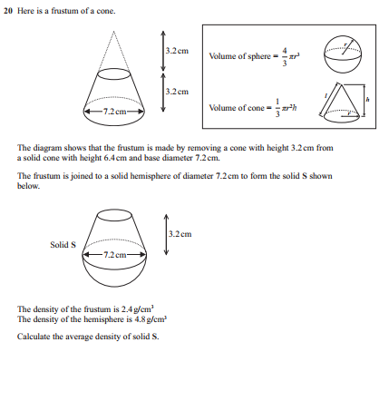
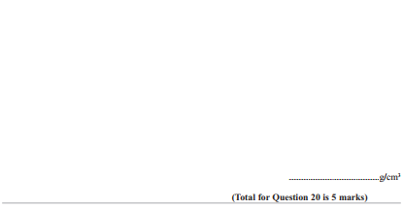
Pearson Edexcel - Thursday 7 June 2018 - Paper 2 (Calculator) Higher Tier
5.
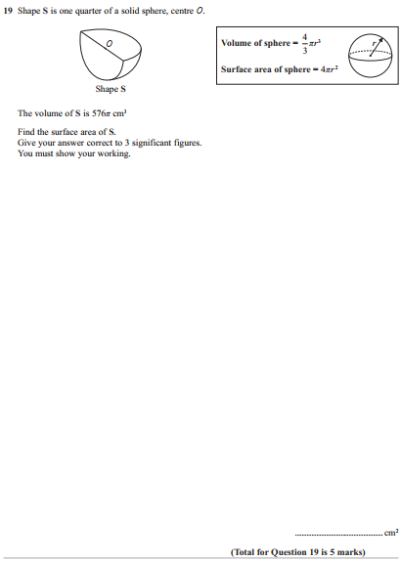

Pearson Edexcel - Tuesday 13 June 2017 - Paper 3 (Calculator) Higher Tier
6.
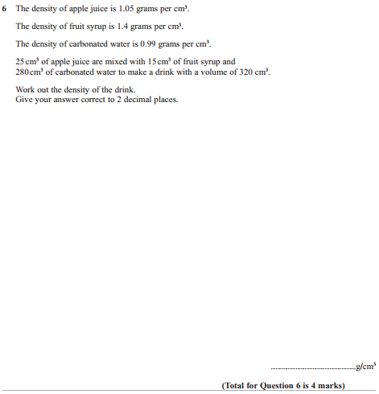

Pearson Edexcel - Specimen Papers Set 2 - Paper 3 (Calculator) Higher Tier
7.
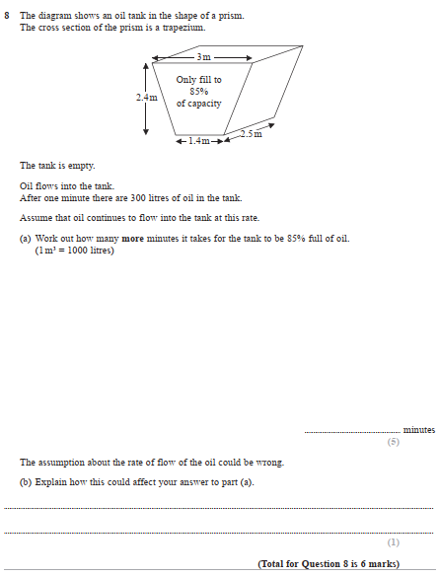

Pearson Edexcel - Specimen Papers Set 2 - Paper 3 (Calculator) Higher Tier
8.
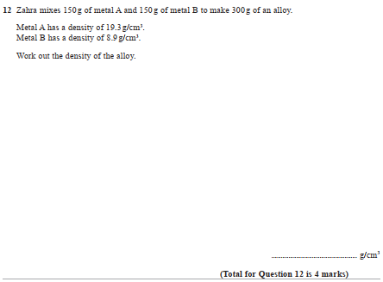

Pearson Edexcel - Specimen Papers Set 1 - Paper 3 (Calculator) Higher Tier
9.
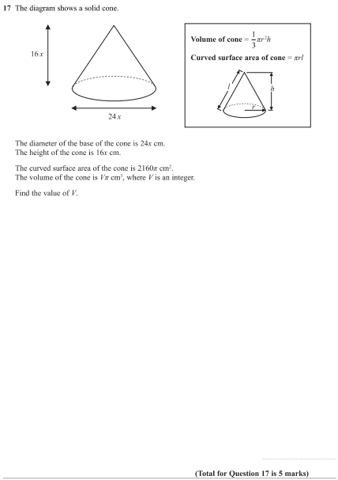

Pearson Edexcel - Thursday 9 June 2016 - Paper 2 (Calculator) Higher Tier
10.
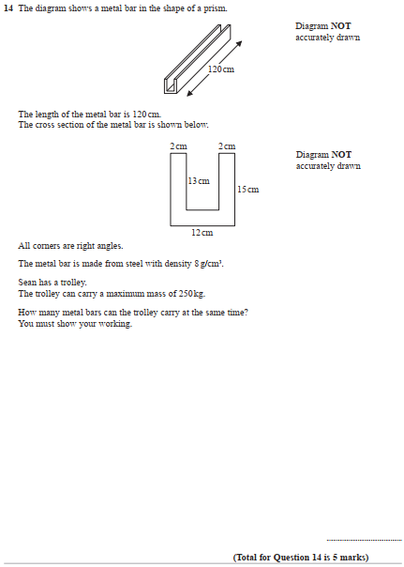

Pearson Edexcel - Wednesday 4 November 2015 - Paper 1 (Non-Calculator) Higher Tier
11.
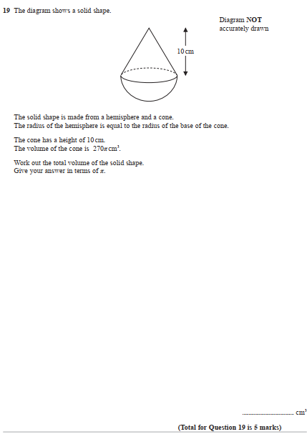

Pearson Edexcel - Monday 8 June 2015 - Paper 2 (Calculator) Higher Tier
12.
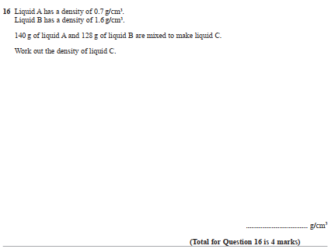

Pearson Edexcel - Wednesday 5 November 2014 - Paper 1 (Non-Calculator) Higher Tier
13.
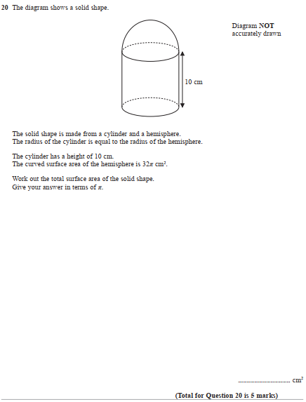

AQA GSCE – Tuesday 21 May 2019 – Paper 1 (Non - Calculator) Higher Tier
14.
